
NavJeevan: Empowering Cleanliness

A Project Report submitted in partial fulfilment of the requirements for the award of the degree of
Bachelor of Technology
in
Computer Science and Engineering

by

Name of Students: Vibhu Dixit

Roll No: 2215001940

Under the Guidance of

Mr. Samarth Sir

Department of Computer Engineering & Applications

Institute of Engineering & Technology

GLA University

Mathura- 281406, INDIA

May, 2019

Department of Computer Engineering and Applications

GLA University, 17 km. Stone NH#2, Mathura-Delhi Road, Chaumuha, Mathura – 281406 U.P (India)

Declaration

I hereby declare that the work which is being presented in the BCA(Hons.). Mini Project “NavJeevan: Empowering Cleanliness”, in partial fulfillment of the requirements for the award of the Bachelor of Technology in Computer Science and Engineering and submitted to the Department of Computer Engineering and Applications of GLA University, Mathura, is an authentic record of my own work carried under the supervision of Mr. Samarth Sharma.
The contents of this project report, in full or in parts, have not been submitted to any other Institute or University for the award of any degree.

Sign ______________________
Name of Candidate: Vibhu Dixit
University Roll No.: 2215001940

Certificate

This is to certify that the project report titled "Navjeevan" has been carried out by Vibhu Dixit(2215001940) under Mr. Samarth Sharma guidance. This work is submitted in partial fulfilment of the requirements for the degree of Bachelor of Technology in Computer Science and Engineering.

Mr. Samarth Sharma
GLA University, Mathura

ACKNOWLEDGEMENT

We are deeply grateful to everyone who supported us throughout the development of this project, "Navjeevan: Empowering Cleanliness". This project marks an important milestone in our academic journey, and it would not have been possible without the guidance and encouragement of several individuals and organizations.
First and foremost, we would like to express our heartfelt gratitude to our project supervisor, Mr. Samarth Sharma, for his invaluable guidance, constant motivation, and immense support. His expertise and constructive feedback were instrumental in shaping our ideas and ensuring the success of this project. His timely suggestions and insightful advice have been crucial in every stage of this project.
We extend our sincere thanks to the Department of Computer Engineering and Applications, GLA University, for providing us with the resources and infrastructure required to undertake this project. The conducive academic environment and access to necessary tools and technologies were crucial in bringing our concept to fruition.
We would also like to acknowledge the unwavering support of our parents and family members, whose encouragement kept us focused and motivated throughout the process. Their understanding and belief in our abilities were our greatest strengths.
Additionally, we thank our peers and team members, Vibhu Dixit (2215001940) for their collaboration, dedication, and hard work. Working together on this project has been a deeply enriching experience that strengthened our technical and interpersonal skills.
Finally, we are thankful to all the individuals and organizations whose online tutorials, articles, and open-source resources provided insights and technical solutions during challenging phases of our project.

Sign ______________________
Name of Candidate: Vibhu Dixit
University Roll No.: 2215001940

ABSTRACT

Navjeevan is a web-based platform aimed at addressing cleanliness issues and promoting sustainable practices. Users can upload area-specific problems like garbage disposal issues with accompanying images, which are directly sent to the respective municipal authority for resolution. The platform also includes features like:
- A business page to promote the sale of reusable items.
- An Instagram-like interface for user interaction.
- An admin module for overseeing and managing area-specific problems.
- A reward system where users earn redeemable points for reporting issues.
This project utilizes a robust MERN stack architecture to provide a seamless user experience. It is designed to enhance community cleanliness and encourage environmental responsibility.

 | S.NO | Topic
 | 1 | Introduction/ abstract/title
 | 2 | System Requirements
 | 3 | Hardware Requirements
 | 4 | Front End and Back End
 | 5 | Idea
 | 6 | Objective
 | 7 | Complete Code
 | 8 | Screenshot Working
 | 9 | DFD (0level 1 level and 2 level)
 | 10 | Bibliography
11 |  | References

About the Project

Primary Reason to Choose This Project
To promote cleanliness and environmental responsibility by providing a platform for users to report and resolve area-specific cleanliness issues while fostering sustainable practices.

Main Objective of the Project
To create an easy-to-use platform for reporting cleanliness issues, managing reusable items, and engaging the community through interactive features and rewards.

Scope of the Project
- Implementation at local or municipal levels for effective cleanliness management.
- Potential expansion to include waste segregation and recycling features.

Working Methodology of the Project
- User Action: Users upload issues with descriptions and images.
- Routing: Issues are routed to the relevant authority for action.
- Admin Oversight: Admins manage user reports and provide resolution updates.
- Rewards System: Users earn points for uploading valid reports, which can be redeemed for rewards.

System Requirement

Supported Operating Systems
The platform is designed to run seamlessly on various operating systems:
- Windows:
  - Versions: Windows 10 and above.
  - Minimum Build: 1909 or later for optimal compatibility.
- Linux:
  - Distributions: Ubuntu 18.04 and above, Fedora, Debian.
  - Kernel Version: 5.x or later recommended.
- macOS:
  - Versions: macOS Mojave (10.14) and above.
  - Processor Compatibility: Intel-based and Apple Silicon (M1,M2).

Software Requirements
The project requires the following software components:
- Development Environment:
  - IDE/Editor: Visual Studio Code, IntelliJ IDEA, or any preferred text editor with Node.js and React plugins.
  - Version Control: Git (GitHub or GitLab for repository management).
- Frontend:
  - Languages: HTML5, CSS3, JavaScript.
  - Frameworks/Libraries:
    - React.js for UI development.
    - Bootstrap for responsive design.
- Backend:
  - Languages: JavaScript (Node.js).
  - Frameworks: Express.js for building APIs.
- Database:
  - MongoDB (NoSQL database) with tools like MongoDB Atlas for cloud deployment or a locally hosted instance.
- APIs and Integrations:
  - External APIs for location detection (e.g., Google Maps API).
  - Notification services (e.g., Firebase or OneSignal for push notifications).
- Other Tools:
  - Cloud Platforms: AWS, Microsoft Azure, or Heroku for hosting.

Hardware Requirements
Detailed hardware specifications for running the project include:
Development Environment:
- Processor:
  - Minimum: Intel Core i3 (7th Gen) or AMD Ryzen 3.
  - Recommended: Intel Core i5/i7 or AMD Ryzen 5/7.
- RAM:
  - Minimum: 4 GB.
  - Recommended: 8 GB or more for smooth multitasking during development.
- Storage:
  - Minimum: 50 GB free space for project files and software installation.
  - Recommended: SSD storage for faster read/write operations.
- Graphics:
  - Integrated graphics card sufficient for development purposes.
  - Discrete GPU (NVIDIA/AMD) recommended for enhanced performance during UI testing or design.
Server/Hosting Environment:
- Processor: Multi-core (2 GHz or above).
- RAM: Minimum 8 GB for handling simultaneous user requests.
- Storage: 100 GB or more depending on user data (images, issue reports).
- Network: Minimum bandwidth of 10 Mbps for efficient user interaction and database synchronization.

Frontend and Backend

Frontend
The frontend of "Navjeevan" is designed to be user-friendly, responsive, and intuitive. It provides an interactive interface for users to upload issues, view updates, and explore other platform features.
Technologies Used
- React.js: A JavaScript library for building user interfaces.
- HTML5: For structuring the web pages.
- CSS3: For styling the application and ensuring responsiveness.
- Bootstrap: For prebuilt responsive design components and layouts.
- Axios: For making API requests to the backend.

Backend
The backend of "Navjeevan" handles data storage, retrieval, and communication between the frontend and the server. It ensures secure and efficient management of user data and issues.

Technologies Used
- Node.js: JavaScript runtime environment for server-side programming.
- Express.js: Web framework for creating API endpoints.
- MongoDB: NoSQL database for flexible and scalable data storage.
- Mongoose: ODM (Object Data Modeling) library for MongoDB and Node.js.
- JWT (JSON Web Tokens): For secure user authentication.
- Cloudinary: For managing and storing uploaded images.

Idea of the Project: "Navjeevan"
Purpose:
"Navjeevan" aims to solve urban cleanliness issues by creating a platform where citizens can report problems, and authorities can take swift action. It also promotes sustainability by encouraging the reuse of items and rewarding active participation.
How It Works:
- User Reporting:
  - Users can log in and report cleanliness problems like garbage piles or clogged drains.
  - Each report includes a description and images for better clarity.
  - The report is sent directly to the concerned municipal authority for action.
- Sustainability Features:
  - A business page allows users to sell reusable items, reducing waste and promoting a circular economy.
  - This feature connects users to sustainable practices while minimizing environmental impact.
- Community Engagement:
  - The platform has an Instagram-like interface where users can interact with posts, comment, and share ideas.
  - This creates a sense of community, motivating users to actively participate in cleanliness initiatives.
- Reward System:
  - Users earn points for reporting valid issues.
  - These points can be redeemed for coupons or goodies, making cleanliness reporting engaging and rewarding.
- Admin Oversight:
  - An admin panel ensures reports are reviewed and assigned to the correct authority.
  - Admins also oversee the reward system and monitor platform activity for smooth operations.
Why It’s Needed:
- Urban areas often face delayed responses to cleanliness issues.
- Sustainable waste management practices are underutilized.
- Community involvement in cleanliness efforts is low.
Conclusion:
"Navjeevan" bridges the gap between citizens and municipal authorities, making cleanliness management efficient and user-friendly. It combines technology, sustainability, and community engagement to create a cleaner and greener society.

Objective of the Project
The Navjeevan project is designed to create a user-friendly digital platform that encourages cleanliness and sustainable practices in communities. The main goals are:

- Connecting Citizens and Authorities
- Bridge the gap between citizens and municipal authorities.
- Ensure easy communication for reporting and resolving cleanliness issues.

- Reporting Problems
- Allow users to report problems like garbage accumulation or improper waste disposal.
- Users can upload descriptions with images of the issue.
- Issues are routed directly to municipal authorities for action.

- Promoting Sustainability
- Introduce a business page for buying and selling reusable items.
- Encourage recycling and reduce waste through community involvement.
- Support the circular economy by making sustainable practices accessible.

- Enhancing User Engagement
- Add interactive features inspired by social media (e.g., comments, likes).
- Create a sense of community and encourage active participation.
- Reward users for reporting issues by offering redeemable points for coupons or goodies.

- Efficient Management
- Include an admin module for managing and tracking reported problems.
- Provide tools for assigning issues to the appropriate authorities.
- Ensure transparency with progress tracking and status updates for users.

- Promoting Cleanliness and Awareness
- Motivate users to take responsibility for their surroundings.
- Raise awareness about the importance of a clean and hygienic environment.

Complete Code

const express = require('express');
const app = express();
const path = require('path');
const ejsMate = require('ejs-mate');
const methodOverride = require('method-override');
const mongoose = require('mongoose');
const session = require('express-session');
const loginRoutes = require('./routes/login');
const YourPostRoutes = require('./routes/yourpost');
const eventsRoutes = require('./routes/events');
const walletRoutes = require('./routes/wallet');
const complainRoutes = require('./routes/complain');
const leaderboardRoutes = require('./routes/leaderboard');
const postRoutes = require('./routes/search');
const businessRoutes = require('./routes/business');
const adminRoutes = require('./routes/admin');
const feedbackRoutes = require('./routes/feedback');
const sanitizationRoutes = require('./routes/sanitization');
const desposalRoutes = require('./routes/desposal');
const bodyParser = require('body-parser');
const cors = require('cors');
app.use(cors());
app.use(methodOverride('_method'));
app.engine('ejs', ejsMate);
app.set('view engine', 'ejs');
app.set('views', path.join(__dirname, 'views'));
app.use(express.static(path.join(__dirname, 'public')));
app.use('/uploads', express.static(path.join(__dirname, 'uploads')));
app.use(express.urlencoded({ extended: true }));
app.use(bodyParser.json());
app.use(bodyParser.urlencoded({ extended: true }));

mongoose.connect('mongodb://localhost:27017/swipe2clean', {})
.then(() => console.log('Connected to MongoDB'))
.catch(err => console.error('MongoDB connection error:', err));

app.use(express.urlencoded({ extended: false }));
app.use(session({
secret: 'secret_key',
resave: false,
saveUninitialized: false,
}));

app.use('/posts', postRoutes);
app.use('/home', loginRoutes);
app.use(loginRoutes);
app.use(YourPostRoutes);
app.use(eventsRoutes);
app.use('/events', eventsRoutes);
app.use(walletRoutes);
app.use('/wallet', walletRoutes);
app.use(complainRoutes)
app.use('/compalin', complainRoutes);
app.use(leaderboardRoutes)
app.use('/leaderboard', leaderboardRoutes)
app.use(businessRoutes)
app.use(adminRoutes)
app.use(feedbackRoutes)
app.use(sanitizationRoutes)
app.use(desposalRoutes)

app.get('/', (req, res) => {
res.render('home/index');
});

app.get('*', (req, res) => {
res.render('404/index');
});
app.get('/Err', (req, res) => {
res.render('404/index');
});
app.listen(8000, () => {
console.log("Listening at port 8000!");
});

/Home/index.ejs
<!DOCTYPE html>
<html lang="en">
<head>
<meta charset="UTF-8">
<meta name="viewport" content="width=device-width, initial-scale=1.0">
<title>NavJeevan</title>
<link href="https://cdn.jsdelivr.net/npm/bootstrap@5.3.3/dist/css/bootstrap.min.css" rel="stylesheet" integrity="sha384-QWTKZyjpPEjISv5WaRU9OFeRpok6YctnYmDr5pNlyT2bRjXh0JMhjY6hW+ALEwIH" crossorigin="anonymous">
<link rel="stylesheet" href="/css/style.css">
<link rel="icon" type="image/x-icon" href="/images/logo.jpg">
</head>
<body>
<header >
<div class="navbar">
<div class="logo-container">
<img src="images/logo.jpg" class="logo">
<div class="logo-text">NavJeevan</div>
</div>
<div class="nav-items">
<div><a href="#">Home</a></div>
<div><a href="#Events">Events</a></div>
<div><a href="https://contactvibhu.netlify.app/" target="_blank">Contact</a></div>
<div><a href="/AdminLogin">Admin</a></div>
<div><a href="/BusinessLogin">Business</a></div>
<div><a href="https://mywaste.netlify.app/" target="_blank">3R's✨</a></div>
<div><a href="https://dashboardsihjan.netlify.app/" target="_blank">🗑️</a></div>
<div><a href="https://sanitation2024.netlify.app/" target="_blank">🍁</a></div>
</div>
</div>
</header>
<div class="wrapper" >
<button id="popup" class="feedback-button" onclick="toggle_visibility()" name="Feedback">Feedback</button>
<div id="feedback-main">
<div id="feedback-div">
<form action="/submit-feedback" method="post" class="form" id="feedback-form1" name="form1" enctype="multipart/form-data">
<p class="name">
<input name="userr" type="text" class="validate[required,custom[onlyLetter],length[0,100]] feedback-input" required placeholder="Name" id="feedback-name" />
</p>
<p class="email">
<input name="uemail" type="email" class="validate[required,custom[email]] feedback-input" id="feedback-email" placeholder="Email" required />
</p>
<p class="text">
<textarea name="ucomment" class="validate[required,length[6,300]] feedback-input" id="feedback-comment" required placeholder="Hey, I really love the site but I believe that you could incorporate some ... and also get rid of the ... on the section."></textarea>
</p>
<div class="feedback-submit">
<input type="submit" value="SEND" id="feedback-button-blue" />
</div>
</form>
</div>
</div>

<div class="hero-section" id="home">
<div class="absolute faded-text">INDIA &nbsp; º &nbsp; भारत</div>

<div class="hero-section-left">
<div class="hero-section-heading " >स्वच्छता सर्वोपरी</div>

<div class="hero-section-sub-heading">
<span class="tagline"></span>
</div>

<div class="hero-section-description">
"स्वच्छता मिशन को सफलतापूर्व पूरा करने के लिए आपका सहयोग जरूरी है।
कृपा साथ देने का नया रख कर, हम सब मिल कर एक साफ और स्वस्थ भविष्य बना सकते हैं।"
</div>

<div class="btn" id="btn"><a href="/login">Login/SignUp</a></div>

<div class="bgimg-right"><img src="images/flag.png" alt=""></div>
</div>

<div class="hero-section-right">
<div class="background-image"><img src="images/bgimage.jpg" alt=""></div>
</div>
</div>
<div class="event-section" id="Events">

<h2 class="page-header">Events</h2>

<div class="container">
<div class="item-container">
<div class="img-container">
<img src="images/event-1.png" alt="Event image">
</div>

<div class="body-container">
<div class="overlay"></div>

<div class="event-info">
<p class="title">Cleanathon</p>
<div class="separator"></div>
<p class="info">Mathura</p>
<p class="price">Free</p>

<div class="additional-info">
<p class="info">
<i class="fas fa-map-marker-alt"></i>
Gla university, Mathura
</p>
<p class="info">
<i class="far fa-calendar-alt"></i>
Sat, Oct 14, 10:00 AM EDT
</p>

<p class="info description">
Welcome! A community-driven event dedicated to environmental stewardship.
Join us for a day of cleaning, tree planting, and awareness-raising activities,
creating a cleaner, greener tomorrow for all. <span>more...</span>
</p>
</div>
</div>
<!-- <button class="action">Participate</button> -->
<a href="/login"><button class="action">Participate</button></a>

</div>
</div>

<div class="item-container">
<div class="img-container">
<img src="images/event-2.png" alt="Event image">
</div>

<div class="body-container">
<div class="overlay"></div>

<div class="event-info">
<p class="title">Green Sweep</p>
<div class="separator"></div>
<p class="info">Mathura</p>
<p class="price">Free</p>

<div class="additional-info">
<p class="info">
<i class="fas fa-map-marker-alt"></i>
Gla university, Mathura
</p>
<p class="info">
<i class="far fa-calendar-alt"></i>
Sat, Oct 13, 10:00 AM EDT
</p>

<p class="info description">
Welcome! A community-driven event dedicated to environmental stewardship. Join us for a day of cleaning. Together, we make a difference. <span>more...</span>
</p>
</div>
</div>
<!-- <button class="action">Participate</button> -->
<a href="/login"><button class="action">Participate</button></a>

</div>
</div>

<div class="item-container">
<div class="img-container">
<img src="images/event-3.jpg" alt="Event image">
</div>

<div class="body-container">
<div class="overlay"></div>

<div class="event-info">
<p class="title">Sparkling Streets</p>
<div class="separator"></div>
<p class="info">Mathura</p>
<p class="price">Free</p>

<div class="additional-info">
<p class="info">
<i class="fas fa-map-marker-alt"></i>
Gla university, Mathura
</p>
<p class="info">
<i class="far fa-calendar-alt"></i>
Sat, Oct 10, 10:00 AM EDT
</p>

<p class="info description">
Welcome! A community-driven cleanup extravaganza, transforming neighborhoods into gleaming havens. Join us for change! <span>more...</span>
</p>
</div>
</div>
<!-- <button class="action">Participate</button> -->
<a href="/login"><button class="action">Participate</button></a>

</div>
</div>

<div class="item-container">
<div class="img-container">
<img src="images/event-4.jpg" alt="Event image">
</div>

<div class="body-container">
<div class="overlay"></div>

<div class="event-info">
<p class="title">Clean and Green Rally</p>
<div class="separator"></div>
<p class="info">Mathura</p>
<p class="price">Free</p>

<div class="additional-info">
<p class="info">
<i class="fas fa-map-marker-alt"></i>
Gla university, Mathura
</p>
<p class="info">
<i class="far fa-calendar-alt"></i>
Sat, Oct 17, 10:00 AM EDT
</p>

<p class="info description">
Welcome! Join us for a community event advocating eco-consciousness and a litter-free environment.<span>more...</span>
</p>
</div>
</div>
<!-- <button class="action">Participate</button> -->
<a href="/login"><button class="action">Participate</button></a>
</div>
</div>
</div>
</div>
</div>
</div>

<footer id="Contact">
<div class="content">
<div class="left box">
<div class="upper">
<div class="topic">About us</div>
<p>NavJeevan revolutionizes domestic waste management with a user-friendly platform. We empower individuals
to effortlessly schedule, track, and optimize waste collection, promoting a greener, more sustainable future
for communities worldwide.</p>
</div>
<div class="lower">
<div class="topic">Contact us</div>
<div class="phone">
<a href="#"><i class="fas fa-phone-volume"></i>+91 7500211114</a>
</div>
<div class="email">
<a href="https://nagarnigamagra.com/contacts/"><i class="fas fa-envelope"></i>NavJeevan@gmail.com</a>
</div>
</div>
</div>
<div class="middle box">
<div class="topic">Our Services</div>
<div><a href="https://aarogyasetu.gov.in/">AarogyaSetu</a></div>
<div><a href="https://nagarnigamagra.com/">NagarNigamAgra</a></div>
<div><a href="https://swachhbharatmission.gov.in/sbmcms/index.htm">SwachBharat</a></div>
<div><a href="https://www.india.gov.in/">BharatSarkaar</a></div>
<div><a href="https://www.safaikarmachariandolan.org/">SafaiAndolan</a></div>

</div>
<div class="right box">
<div class="topic">Get Notifications</div>
<form name="submit-to-google-sheet" method="post">
<input type="text" placeholder="Enter email address" name="email">
<input type="submit" value="Send">
</form>
<span id="msg"></span>
<div class="media-icons">
<a href="https://www.facebook.com/groups/2792504170785222/"><i class="fab fa-facebook-f"></i></a>
<a href="https://www.instagram.com/agranagarnigam/"><i class="fab fa-instagram"></i></a>
<a href="https://twitter.com/agranagarnigam?lang=en"><i class="fab fa-twitter"></i></a>
<a href="https://www.youtube.com/user/narendramodi"><i class="fab fa-youtube"></i></a>
<a href="https://www.linkedin.com/company/nagar-palika-nigam/about/"><i class="fab fa-linkedin-in"></i></a>
</div>
</form>
</div>
</div>
<div class="bottom">
<p>Copyright © 2020 <a href="#">NavJeevan</a> All rights reserved</p>
</div>
</footer>

<script src="https://cdn.jsdelivr.net/npm/typed.js@2.0.12"></script>
<script src="https://kit.fontawesome.com/58a810656e.js" crossorigin="anonymous"></script>
<script>
var typeData = new Typed(".tagline", {
strings: [
"स्वच्छ घर, स्वस्थ भविष्य",
"आपका कचरा, हमारी ज़िम्मेदारी",
"कचरा नहीं, संसाधन",
"घरेलु कचरा प्रबंधन मिशन",
"स्वच्छ घर, स्वच्छ भारत",
"कूड़ा नहीं, कुशलता",

],
loop: true,
typeSpeed: 100,
backSpeed: 80,
backDelay: 1000,
});
</script>

<script>
function toggle_visibility() {
var e = document.getElementById('feedback-main');
if(e.style.display == 'block')
e.style.display = 'none';
else
e.style.display = 'block';
}
</script>
<script>
document.getElementById('feedback-form1').addEventListener('submit', async (e) => {
e.preventDefault();

const formData = new FormData(e.target);
const data = Object.fromEntries(formData.entries());

try {
const response = await fetch('/submit-feedback', {
method: 'POST',
headers: {
'Content-Type': 'application/json'
},
body: JSON.stringify(data)
});

const result = await response.json();

if (response.ok) {
alert(result.message); // "Feedback submitted successfully!"
e.target.reset(); // Clear form on success
} else {
alert(result.message || 'Error submitting feedback.'); // Show error message
console.error(result.errors || 'Unknown error');
}
} catch (error) {
console.error('Request failed:', error);
alert('Error submitting feedback. Please try again later.');
}
});

</script>

<script>
const scriptURL = 'https://script.google.com/macros/s/AKfycbxBqQd2m4ea_XLp2zM1fWuOCpWPkZ9wxFirITjQWMuhC1zFXb4Lvu7gGSAIcOkc0URZKA/exec'
const form = document.forms['submit-to-google-sheet']
const msg=document.getElementById('msg')
form.addEventListener('submit', e => {
e.preventDefault()
fetch(scriptURL, { method: 'POST', body: new FormData(form)})
.then(response => {
msg.innerHTML="Thank you for submission"
})
.catch(error => console.error('Error!', error.message))
})
</script>

</body>
</html>
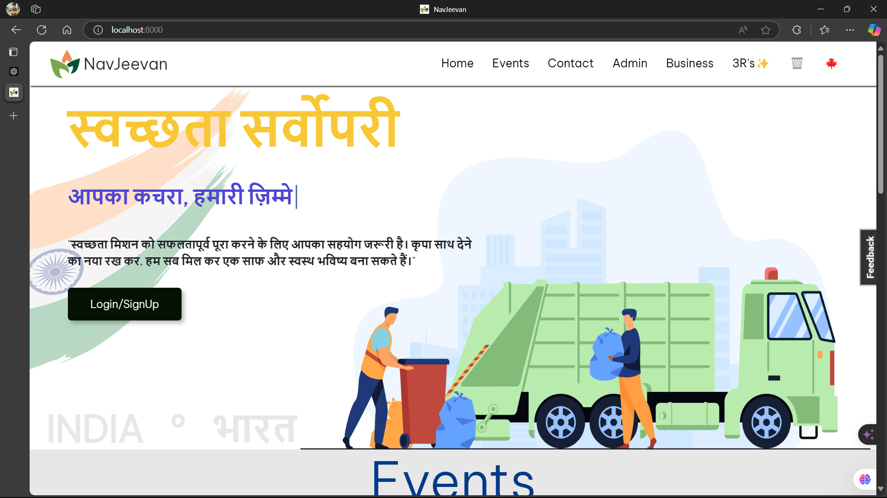
Screenshot Working
1-Main Screen
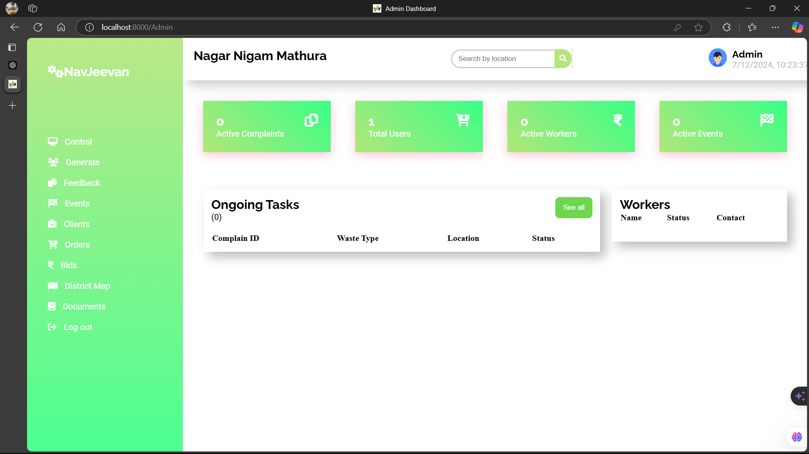
2-Admin Dasboard

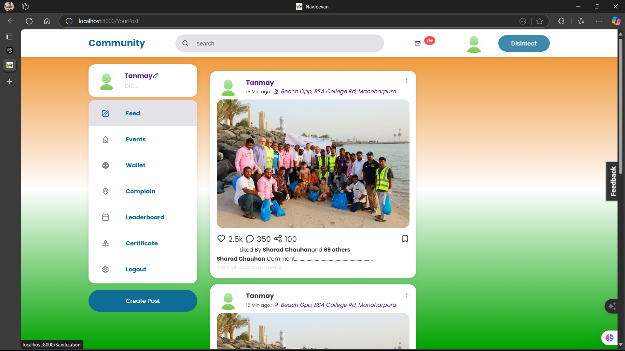
3-User Dashboard
DFD(0lvl, 1lvl, 2lvl)

    - 0lvl DFD
    - 1lvl DFD

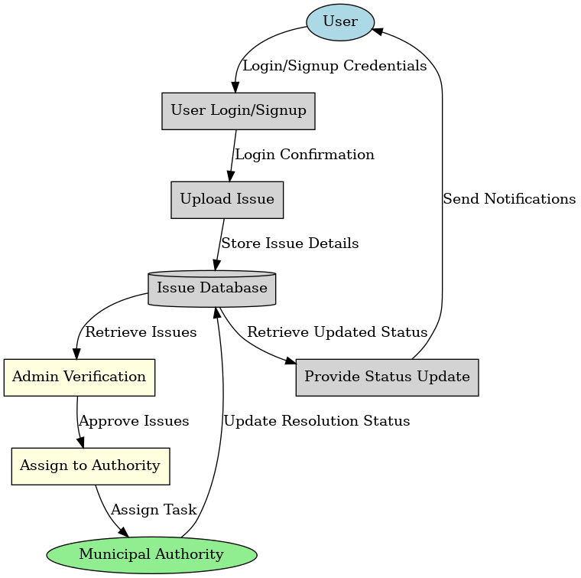
    - 2lvl DFD
Bibliography

W3Schools. (2020). HTML, CSS, JavaScript Tutorials.
W3Schools served as a valuable online resource for basic web development techniques. The tutorials provided on HTML, CSS, and JavaScript were critical in building the website’s layout and frontend functionality, including the business page and interactive user elements such as forms and buttons. These resources were used to design responsive and accessible UI elements.

MongoDB Documentation (2020). MongoDB: The Definitive Guide.
This comprehensive guide offered valuable insights into using MongoDB as a NoSQL database to manage user and issue data efficiently. It helped optimize the database structure to store user-submitted issues, track their status, and maintain a secure connection between the database and the backend system.

Mern Stack Documentation (2021). MongoDB, Express.js, React, Node.js.Documentation.
The official MERN stack documentation provided the foundational knowledge for implementing the full-stack architecture of the project. It allowed us to seamlessly integrate MongoDB for data storage, React for the frontend user interface, and Express.js and Node.js for backend operations, ensuring smooth communication between the different components.

REFERENCES
- MERN Stack Documentation
- Bootstrap Framework
- MongoDB Guides

